F1 (one family) KOST=11/12/13: 2nd stage (SS) shear stress

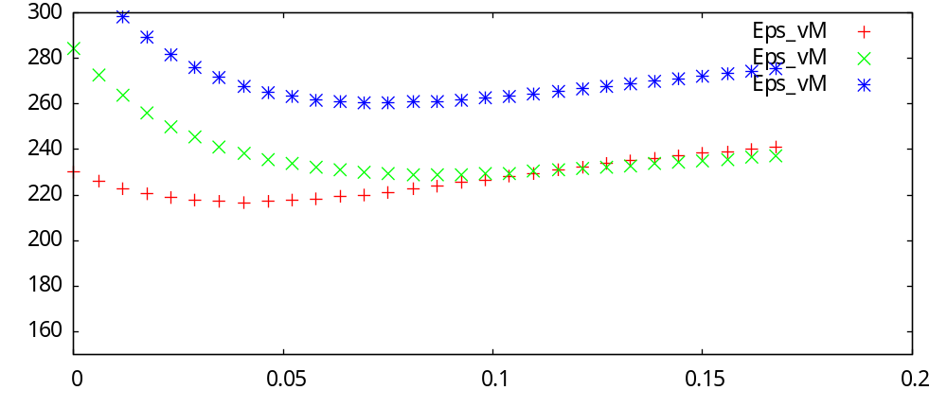
F2 (two families) KOST=11/12/13: 2nd stage (SS) shear stress
